Prepare your farming business for a no-deal Brexit

Introduction
DEFRA have issued guidance to farmers for the potential changes which you need to make to prepare your farming business for a no-deal Brexit. The original guidance was published on18 February 2019 and has recently been updated to take account of recent developments.
The areas covered by the update are:
- Stay up to date
- Farm and rural payments: EU funding
- Importing and exporting
- Your employees
- Employing seasonal workers
- Food and drink labelling including organic produce
- Marketing standards
- Genetically modified organisms (GMOs)
- Fertilisers
- Pesticides regulations
- Chemical regulations
- Water regulations

Stay up to date
The UK will leave the EU on 31 October 2019. This document tells you some of the areas to prepare for Brexit. DEFRA are continuing to their advice weekly so please sign up for updates below:.
Sign up for government-wide email alerts about Brexit.
Sign up for Defra alerts about Brexit and the farming sector.

Farm and rural payments: EU funding
In 2019, EU funding for rural payment schemes including the Basic Payment Scheme will continue, whether the UK leaves the EU with or without a deal.
To get payments, you’ll need to follow the same standards as you do now. This includes on-site inspections to UK farms. The Rural Payments Agency (RPA) will continue to administer the schemes.
You’ll continue to receive Rural Development Programme for England (RDPE) funding that comes from the EU until your project closes.
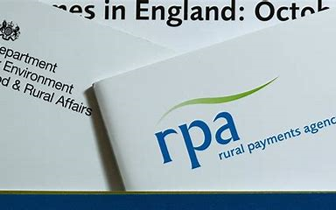

Importing and exporting
To continue importing or exporting products between the UK and EU you must:
- Get a UK Economic Operator Registration and Identification (EORI) number.
- Decide if you want to hire an import-export agent, or make the declarations yourself.
- Contact the organisation that moves your goods to find out what information they need to make the declarations for your goods, or if you will need to make them yourself.
Read the guidance on simplified customs procedures for trading with the EU if we leave without a deal.
Further information is provided in HMRC’s advice for businesses trading with the EU.

Preparing to move goods between Ireland and Northern Ireland
Goods moving between Ireland and Northern Ireland will have different procedures compared to other UK-EU trade.
Read the guidance on customs procedures and VAT for goods moving between Ireland and Northern Ireland.
As negotiations continue ahead of the 31 October deadline, these procedures could be updated to reflect the final deal, if one is reached.

Preparing for changes to existing trade agreements
The way you access existing favourable arrangements with non-EU countries may change.
Read the guidance on changes to trading with non-EU countries that have a free trade agreement with the EU.

Preparing for changes to import tariffs
The UK would implement a temporary tariff regime for up to 12 months.
Most UK imports would be tariff-free, but in certain sectors, such as agriculture, tariffs would be maintained.
Check the temporary rates of customs duty on imports after Brexit.

Arable and horticulture: plants and plant products
Plants and plant products (for example, vegetables, seeds and fruit) managed under the EU plant passport scheme will be subject to UK import controls.

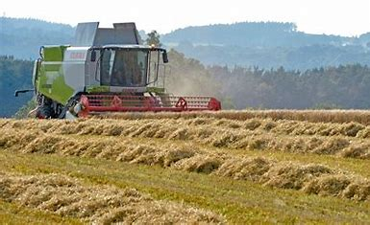
There is a new process you must follow for imports and exports.
Read the guidance on importing and exporting plants and plant products if there’s no withdrawal deal and plant health controls.

Seed exports
You’ll need to list the seed variety you’re exporting on the EU Common Catalogue via a member state.

Livestock, animal products and high-risk feed
The way you import and notify the UK authorities of these imports will change.
If you export animals or animal products from the UK to the EU, you’ll need to follow a new process.
Read the guidance on importing high-risk food and feed not of animal origin if the UK leaves the EU with no-deal and importing and exporting live animals and animal products.

Animal breeding imports and exports (zootechnics)
Unless the EU lists UK breed societies and studbooks you will not be able to export animals to the EU on zootechnical terms.
Imports from the EU, and domestic UK zootechnical trade, will not be affected.
Read the guidance on changes to zootechnical rules if the UK leaves the EU with no-deal.
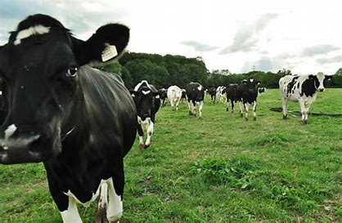

Organic imports and exports
To import from third countries from day 1, you must use the interim paper-based system that will replace TRACES NT.
Unless the EU gives the UK official recognition for our organic standards (known as ‘equivalency’), you cannot export UK organic products to the EU.
Find out more about trading and labelling organic food if there’s no Brexit deal.
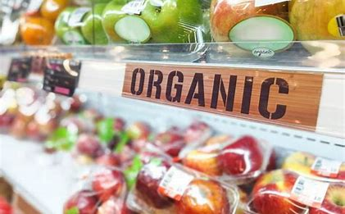

Your employees
There are certain schemes and processes you should be aware of if you employ people.
Find out more in Employing EU, EEA and Swiss citizens and their family members after Brexit.

Employing seasonal workers
You’ll still be able to employ seasonal workers from the EU. European Temporary Leave to Remain will allow EEA citizens arriving in the UK after 31 October 2019 to live, work and study in the UK if there’s no Brexit deal.
You can use the EU seasonal worker information for employers to give further details to your employees.

Food and drink labelling including organic produce
If you’re involved in the agri-food business, labelling rules will change for some food and drink.
Read more in the guidance food labelling changes after Brexit.

Marketing standards
Products that may be subject to changes include:
- fruits and vegetables
- hops
- wine
- beef and veal
- eggs
- hatching eggs and chicks
- poultry meat

UK exports to the EU
Marketing standards inspections on exports will continue.
Until more information is available, exports will need to follow the third country requirements set out in the EC marketing standards regulations.

EU imports to the UK
EU imports to the UK will need to follow the UK’s third country processes for marketing standards. To minimise delays, there will be no inspections on EU imports at the border, however, there will be an increase in checks carried out inland.

Genetically modified organisms (GMOs)
The same controls on the environmental release of GMOs will apply and will be implemented by the competent authorities in the UK.
For more information, see developing genetically modified organisms (GMOs) if there’s no Brexit deal.

Fertilisers
You’ll still be able to buy the same amount and quality of fertiliser. For 2 years after the UK leaves the EU, all products can still be sold under:
- the domestic framework
- the EC fertiliser label
For more information, see manufacturing and marketing fertilisers if there is no Brexit deal.
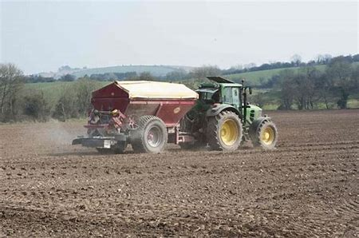

Pesticides regulations
You must meet any new regulations for producing or placing pesticides on the market.
The Health and Safety Executive (HSE) will continue to operate as the UK’s regulator. Read their guidance on regulating pesticides if there’s no-deal.

Chemical regulations
If your business uses chemicals, you should:
- visit the Health and Safety Executive (HSE) website for information on how each of the chemicals regimes will be affected
- read the UK REACH guidance for actions for businesses using chemicals
- check actions for different types of businesses in the HSE’s scenario summary table

Water regulations
You must still meet the conditions in your permits or licences that relate to water. Regulations using the same processes and standards will remain after Brexit.

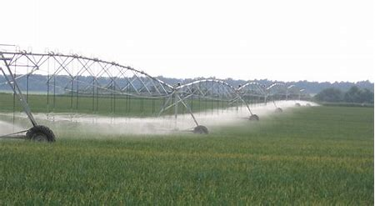
For more information read the water management guidance.
Recommendation
This guidance was last updated on 9 September 2019 and I would advise you to register with DEFRA to receive further updates as they occur.

It is also important to review you business in light of all the areas above and assess the impact and the steps you need to take to be compliant with the new processes and procedures.

Ashley Clarkson FCA BSc(Hons)
Director
AMEC Consultancy Limited
M: 07775 940992
E: ashley@amec-consultancy.co.uk

For more information about AMEC Consultancy and its services, please visit:
www.amec-consultancy.co.uk

Information to readers
This material is published for the information of clients. It provides only an overview of the regulations in force at the date of publication, and no action should be taken without consulting the detailed legislation or seeking professional advice. Therefore no responsibility for the loss occasioned by any person acting or refraining from action as a result of the material can be accepted by the authors or the firm.

